

T

his is currently a shiny application hosted

in EC2

. Data is fetched from quandl API

and can access only freely available data

S

tress Testing model

M

odel to predict and analyse inter correlation betwee

n Macro

variables and metric of choice

A

bhishek Ray

Table of Contents

MACRO ECONOMIC DATA 3

STEP 1: INPUT SECTION 3

ENTER DATA NAME 3

GET TRANSFORMATION 4

GET FREQUENCY 4

STEP 2: OUTPUT 4

TIME SERIES PLOT 5

STEP 3: VIEW METADATA 5

STEP 4: DOWNLOAD HISTORY FILE 5

SIMULATION: CORE VARIABLES 6

INPUT SECTION: CHOOSE CORE VARIABLES 6

CHANGE INITIAL PARAMETERS 7

OUTPUT 7

IMPULSE RESPONSE CHART 7

SIMULATION PROGRESS 8

SIMULATION: NON CORE VARIABLES 9

STEP 1: INPUT SECTION 9

ENTER DATA NAME 9

GET TRANSFORMATION 9

GET FREQUENCY 10

ENTER SIMULATION COUNT 10

ENTER SIGNS FOR OUTLOOK 10

ENTER PERIODS TO FORECAST 10

CHOOSE OUTLOOK 10

STEP2: SELECT PLOT AND DATATABLE VIEW 10

STEP 3: SELECT DISTRIBUTION VIEW 11

STEP4: DOWNLOAD SIMULATION FILE 12

FORECAST MODEL 13

INPUT SECTION FOR INDEPENDANT VARIABLE 13

SELECT CORE VARIABLES 13

SELECT NON-CORE VARIABLES 13

INPUT SECTION FOR DEPENDANT VARIABLE 13

OUTPUT 14

MODEL FIT 14

SUMMARY OF MODEL FIT 15

FORECAST PLOT 15

CURRENT DRAWBACKS 16

STRESS TESTING MANUAL

# MACRO ECONOMIC DATA

In this tab we pull in data from the sources available through the QuandlAPI. We check the data and plot and also view metadata of the said filed to decide whether or not it is suitable for analysis

## STEP 1: INPUT SECTION

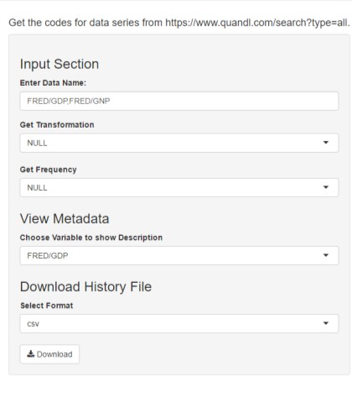

**Figure 1: Macroeconomic Data Input Section**

### ENTER DATA NAME

Here we input the codes for the data as available in Quandl API. The linked to the data is written on the application which is [https://www.quandl.com/search?type=free.](https://www.quandl.com/search?type=free) This will give us a view of all the databases that are available in the free section. On this screen on the quandl website we also have filters on the left hand site as shown below Once we click on a database name, we get to see the available series in the database. Also we see the code as highlighted in the following screen shot.

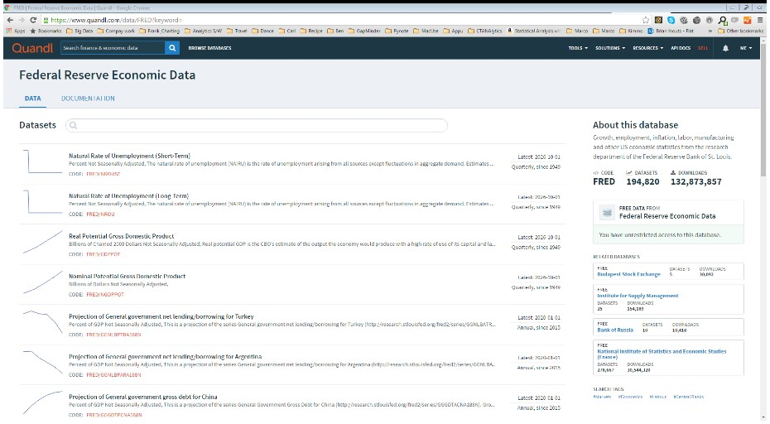

**Figure 2: Quandl site data list**

We should use these codes to fetch data from the quandl api. We can use multiple terms also separated only by a comma and without any quotes.

### GET TRANSFORMATION

In the tool we can set the following transformations. The corresponding values in the parameter field in the following table is to be selected from the dropdown

|  |  |  |  |
| --- | --- | --- | --- |
| **Transformation** | **Parameter** | **Effect** | **Description** |
| **None** | **NULL** | NA | Sends back actual data |
| **Row-on-row change** | **diff** | y’[t] = y[t] - y[t1] | A parameter that will transform the data to show the difference between days. |
| **Row-on-row % change** | **rdiff** | y’[t] = (y[t] - y[t1])/y[t-1] | A parameter that will transform the data to show the difference between days divided by the previous day. |
| **Row-on-row % change from latest value** | **rdiff_from** | y’[t] = (y[n] - y[t])/y[t] | A parameter that will transform the data to show the percentage difference between the latest value and all subsequent values (where y[n] is the latest observation). |
| **Cumulative sum** | **cumul** | y’[t] = y[t] +y[t1] + … + y[0] | A parameter that will calculate the sum of all preceding data returned. |
| **Start at 100** | **normalize** | y’[t] = (y[t]/y[0]) * 100 | A parameter that will normalize the data to the oldest datapoint returned. |

### GET FREQUENCY

Parameters to indicate the desired frequency. When you change the frequency of a dataset, Quandl returns the last observation for the given period e.g. By collapsing a daily dataset to monthly, we will get a sample of the original dataset where the observation for each month is the last data point available for that month. The values that can be selected are none, daily, weekly, monthly, quarterly and annual. If none is selected, then we get back the default data collection frequency of the variables.

## STEP 2: OUTPUT

Next we get the output which consists of two sections

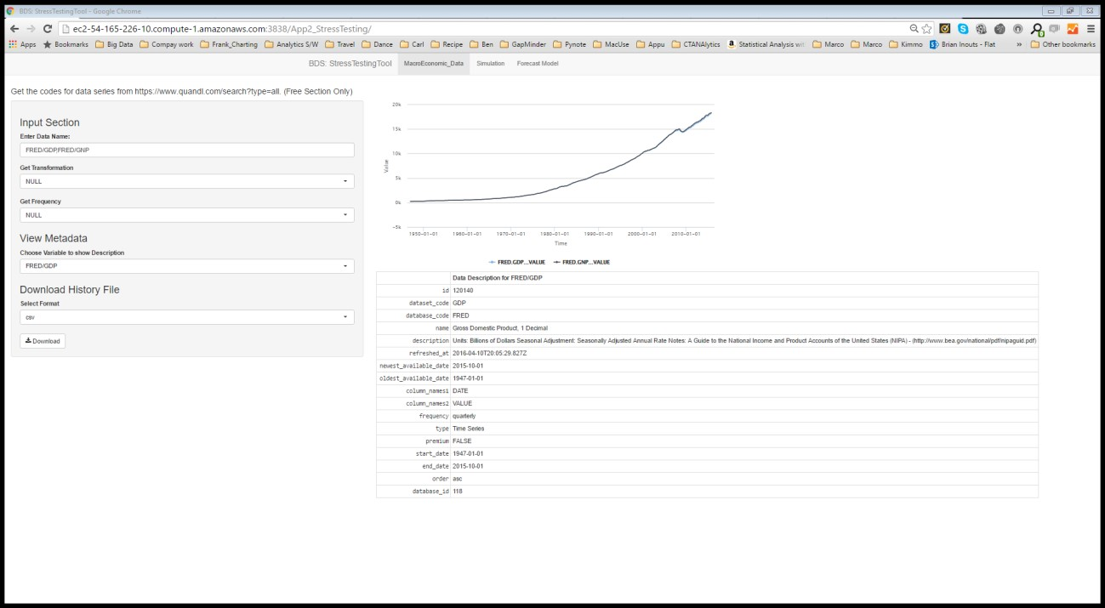

**Figure 3: Output Macroeconomic data**

### TIME SERIES PLOT

In the right hand panel of the application, we first get a time series plot of the entire dataset available for the all the series input in the input text box captioned “Enter Data Name”. The time is plotted on the x axis and values on the y axis.

ISSUES

Since we have not asked the time interval for which we want the data, this outputs the entire series available at the source. Apart from that if the series entered vary widely in scale then the plot will become improper to view at since the bigger variable in magnitude might use up the entire Y axis scale.

## STEP 3: VIEW METADATA

Once the above step is complete we see a new dropdown appear in the “View Metadata” Section. In this dropdown we have a list of the series names that we had input in the text box captioned “Enter Data Name”. On changing the series names in this dropdown we get details of the sent data series in the right hand side in the table below the time series plot. Here we can get a brief idea of the dataset, period, any transformation or adjustment done on the data, definition etc.

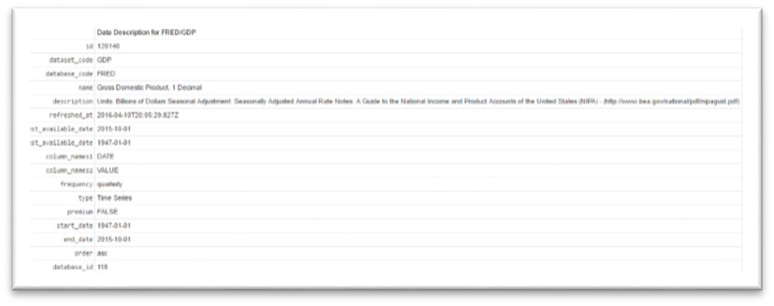

**Figure 4: Data Description Section**

## STEP 4: DOWNLOAD HISTORY FILE

All the data series can be downloaded for the full time period as per chosen frequency and transformation in xls or csv format (as chosen in the dropdown)

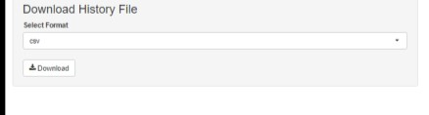

**Figure 5: Download History File**

# SIMULATION: CORE VARIABLES

## Input section: choose core variables

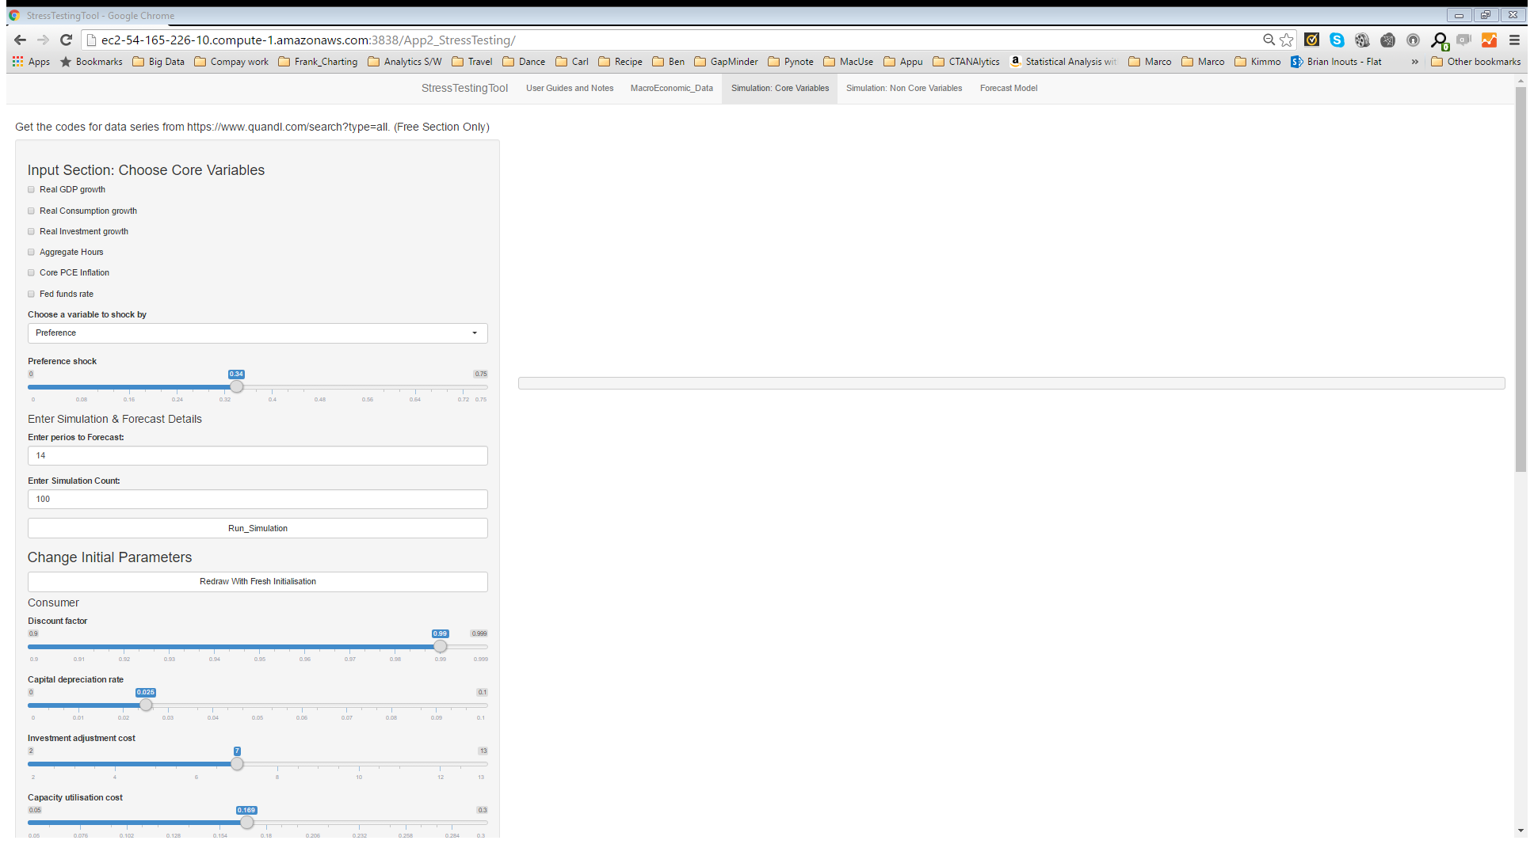

**Figure 6:Core Variables Simulation Input**

Currently we have 6 core variables in the system. Namely,

1. Real GDP growth
2. Real Consumption growth
3. Real Investment growth
4. Aggregate Hours
5. Core Inflation
6. Fed Funds Rate

These are all given as check boxes. We check those variables for which we want to regenerate the simulation.

The idea is to use a shock variable from the following (in the dropdown names “Choose a variable to shock by”)

1. Preference
2. Labour Supply
3. Investment
4. Productivity
5. Wage Mark up
6. Price Mark up
7. Government Spending
8. Interest Rates
9. Inflation Objective

to create a stressed situation or reflect current policy changes. Below the dropdown we have a slider that helps us to choose the magnitude of the shock. Below that we enter the number of periods for which we want to simulate or forecast and then the number of simulations per period.

## Change initial parameters

Here we change the initial parameters of the DGSE model based on Smets Wouters, to more reflect the current economy, policy, labour and consumer behaviour pattern. The initial parameters currently given are

1. Discount factor
2. Capital depreciation rate
3. Investment adjustment cost
4. Capacity utilisation cost
5. Relative risk aversion
6. Habit formation intensity
7. Labour elasticity with respect to wage
8. Labour disutility
9. Capital share in output
10. Indexation for non-optimising workers
11. Wage mark-up
12. Probability of missing wage change signal
13. Indexation for non-optimising firms
14. Probability of missing price-change signal
15. Weight given by monetary authority to inflation

The magnitude of each of the above is represented by a slider and the user can change it according to context of use

## Output

### Impulse Response Chart

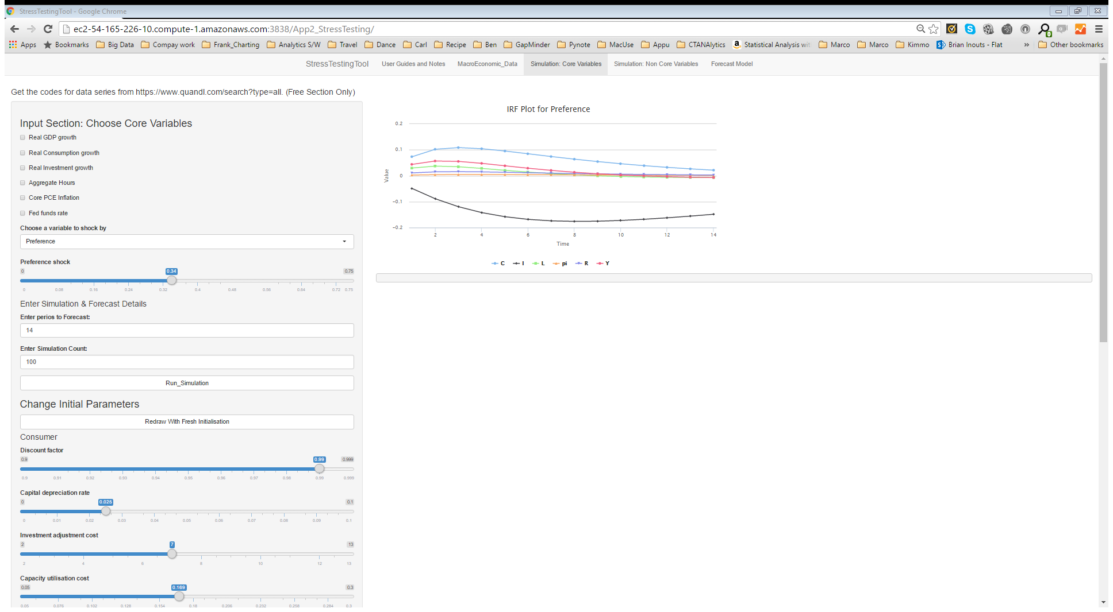

Figure 7: Impulse Response Function

This gives us a impulse response or change in the core variable across the forecast period with respect to the shock and initial parameters.

The legends are as follows

1. Y represents GDP or aggregate production growth
2. C represents Real consumption growth
3. I represent Real Investment Growth
4. L represents aggregate hours of labour
5. R represents Fed rate
6. Pi represents inflation

### Simulation progress

On clicking the Run_Simulation button we see a simulation complete notification in the output section

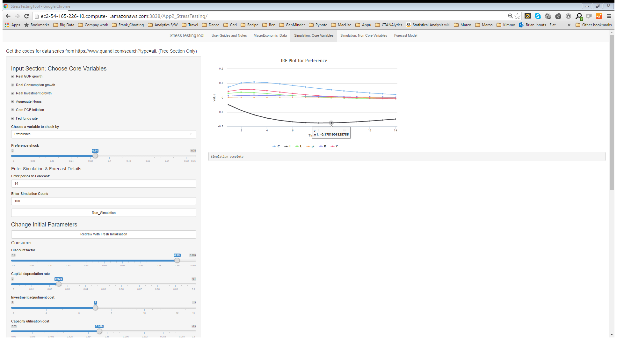

Figure 8: Simulation progress

# SIMULATION: NON CORE VARIABLES

In this Tab we generate and modulate the simulations.

## STEP 1: INPUT SECTION

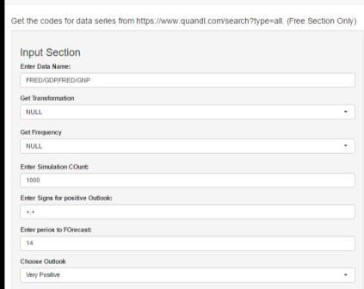

**Figure 9: Simulation Input Section**

### ENTER DATA NAME

Here we input the codes for the data as available in Quandl API. The linked to the data is written on the application which is [https://www.quandl.com/search?type=free.](https://www.quandl.com/search?type=free) This will give us a view of all the databases that are available in the free section. On this screen on the quandl website we also have filters on the left hand site as shown below Once we click on a database name, we get to see the available series in the database. Also we see the code as highlighted in the figure 2.

### GET TRANSFORMATION

In the tool we can set the following transformations. The corresponding values in the parameter field in the following table is to be selected from the dropdown

|  |  |  |  |
| --- | --- | --- | --- |
| **Transformation** | **Parameter** | **Effect** | **Description** |
| **None** | **NULL** | NA | Sends back actual data |
| **Row-on-row change** | **diff** | y’[t] = y[t] - y[t1] | A parameter that will transform the data to show the difference between days. |
| **Row-on-row % change** | **rdiff** | y’[t] = (y[t] - y[t1])/y[t-1] | A parameter that will transform the data to show the difference between days divided by the previous day. |
| **Row-on-row % change from latest value** | **rdiff_from** | y’[t] = (y[n] - y[t])/y[t] | A parameter that will transform the data to show the percentage difference between the latest value and all subsequent values (where y[n] is the latest observation). |
| **Cumulative sum** | **cumul** | y’[t] = y[t] +y[t1] + … + y[0] | A parameter that will calculate the sum of all preceding data returned. |
| **Start at 100** | **normalize** | y’[t] = (y[t]/y[0]) * 100 | A parameter that will normalize the data to the oldest datapoint returned. |

### GET FREQUENCY

Parameters to indicate the desired frequency. When you change the frequency of a dataset, Quandl returns the last observation for the given period e.g. By collapsing a daily dataset to monthly, we will get a sample of the original dataset where the observation for each month is the last data point available for that month. The values that can be selected are none, daily, weekly, monthly, quarterly and annual. If none is selected, then we get back the default data collection frequency of the variables.

### ENTER SIMULATION COUNT

This is the number of paths we would want the tool to simulate

### ENTER SIGNS FOR OUTLOOK

Here we enter the signs in a comma separated string for each of the input series name in the “Enter Data Name” textbox. Plus(+) sign means that increase in the variable signifies a better economy e.g. GDP, whereas Minus(-) sign means that increase in variable signifies worse economy e.g. inflation, unemployment rate, etc.

### ENTER PERIODS TO FORECAST

This is the number of periods we ultimately would want to forecast the metric of our choice. This is also the number of periods for which the macro variables are simulated.

### CHOOSE OUTLOOK

This is a 5-point scale i.e. Very Positive, Positive, Neutral, Negative and Very Negative. Here we respectively take 5%-tile, 25%-tile, 50%-tile, 75%-tile and 100%-tile values of the simulations in every period to forecast the metric or show the forecasted economy if the sign for the series is “- “and the reverse order if the sign is “+”.

## STEP2: SELECT PLOT AND DATATABLE VIEW

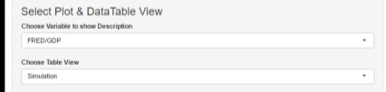

**Figure 10: View for forecast and datatable**

Based on the macro series chosen in the first drop down, we view the forecast plot (for the chosen forecast periods and outlook as in previous section).

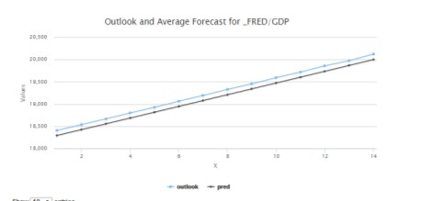

**Figure 11: Forecast Plot**

Based on the second drop down we can either see the period wise simulation for the series chosen in the above dropdown

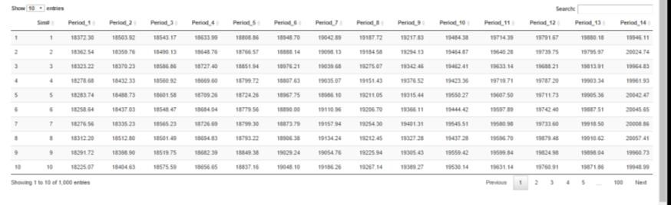

**Figure 12: Simulation Table**

Or we can see the forecast table

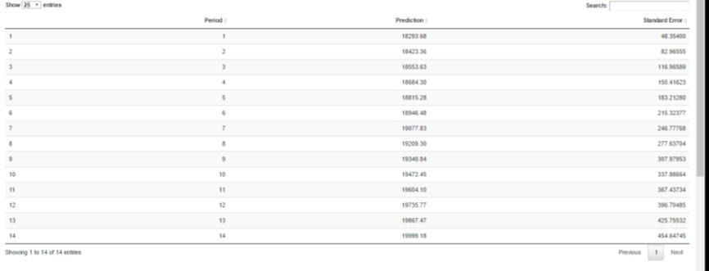

**Figure 12: Forecast Table**

## STEP 3: SELECT DISTRIBUTION VIEW

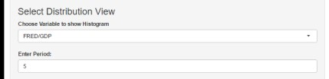

**Figure 11: Distribution Inputs**

Based on the macro series chosen in the dropdown and the period number entered as a integer in the next textbox (which should be less than the user input number of forecasts, since simulation runs till that many periods into the future), we can get the distribution of the simulated variables for that variable in the particular forecast period

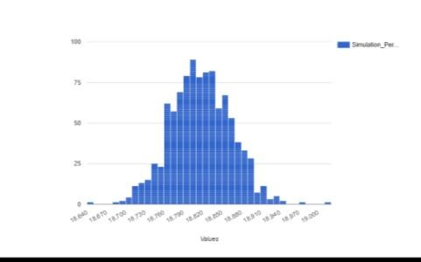

**Figure 13: Distribution Plot**

## STEP4: DOWNLOAD SIMULATION FILE

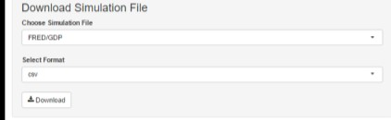

**Figure 14: Download Data Section**

Based on the variable selected in the first drop down and the file format in the next dropdown we can download the generated simulation for all forecast periods into a csv or xls file format.

# Forecast Model

This section is used to forecast any metric of our choice based on the macro variables and based on our hypothesis of the economy and policy, we can check how the metric of our choice should behave based on the simulated forecasts we have generated. This follows a best fitting arimax model.

## Input section for INdependant variable

### Select Core Variables

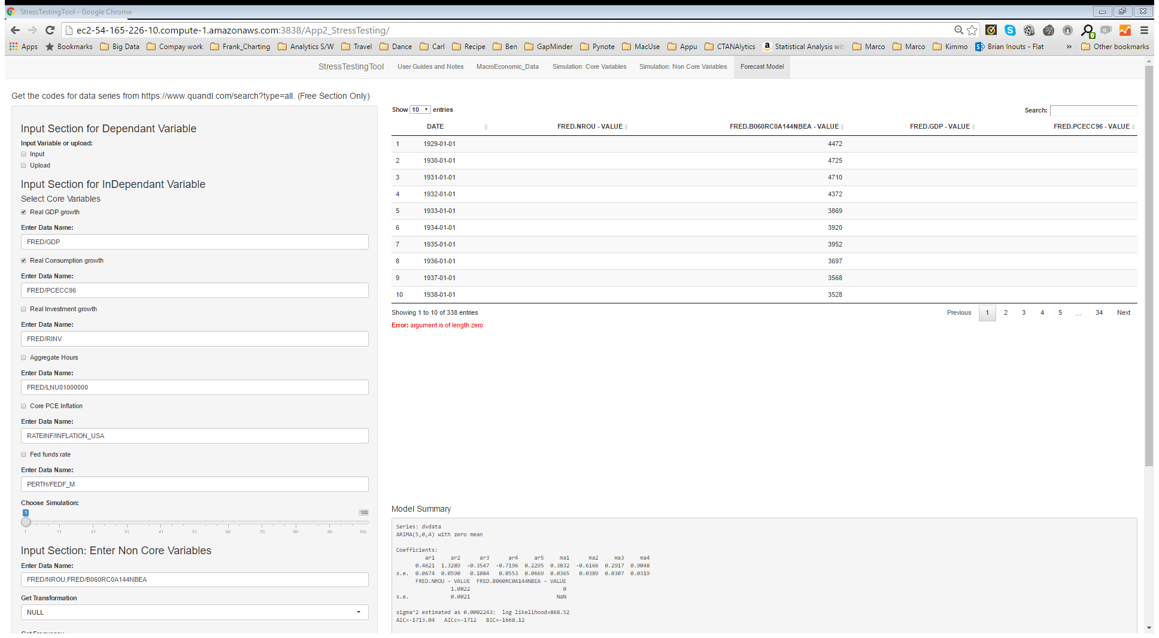

Figure 5: Select core Variables

Here we first check the core variables that we want in our model. Below this we have a slider which gives us the simulation number based on which we want to forecast the metric. Also beside every check box, we have a default code for the series representing the core variable. If we want to substitute that series with any other, we should just change the code in the input text box.

### Select Non-COre Variables

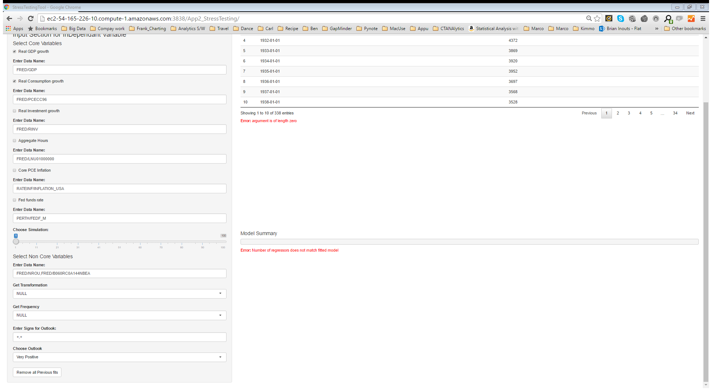

Figure 16: Select Non Core Variables

As previously done we input the codes of the non-core variables for which we generated simulation for in the previous section, and the corresponding transformation and frequency, that we want to include in the model. Please note these should be same as the section in Simulation of non Core variables, else the program will not find the simulation of the non core variables.

## Input section for dependant variable

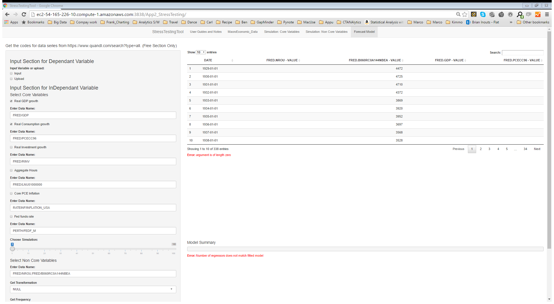

Figure 17: Input Section for Dependant Variable

Here we have two options, one is using a series that is available in the database. In that case we select Input and enter the code of that series in the input text box that appears on checking the input textbox.

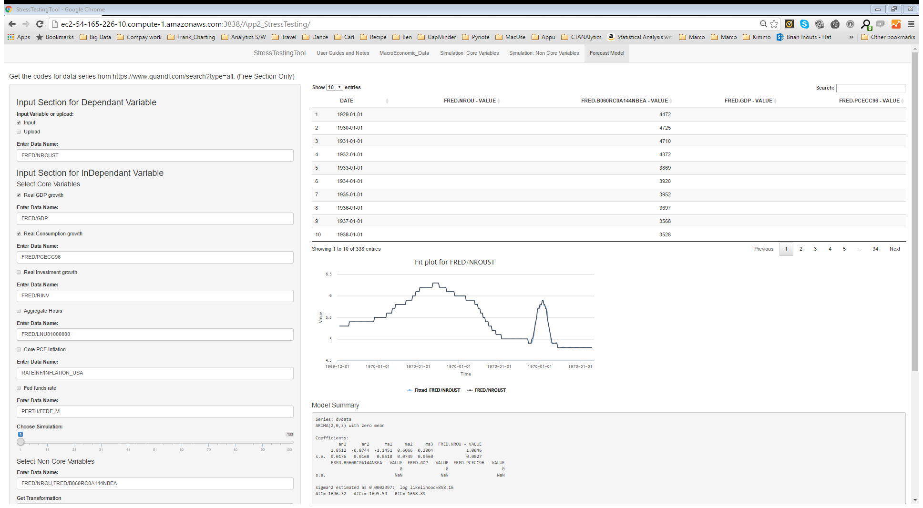

Figure 18: Input Series for Dependant Variable

In this case it will automatically adjust the dates and run the time series.

However, if we want to input our own metric, we must create a csv in the following format, the first column should be dates in YYYY-MM-DD format and the second column should be magnitude of the metric. The metric header should be the name of the metric and the date field should have header DATE. This file should have the same frequency and the dates as shown in the topmost output table

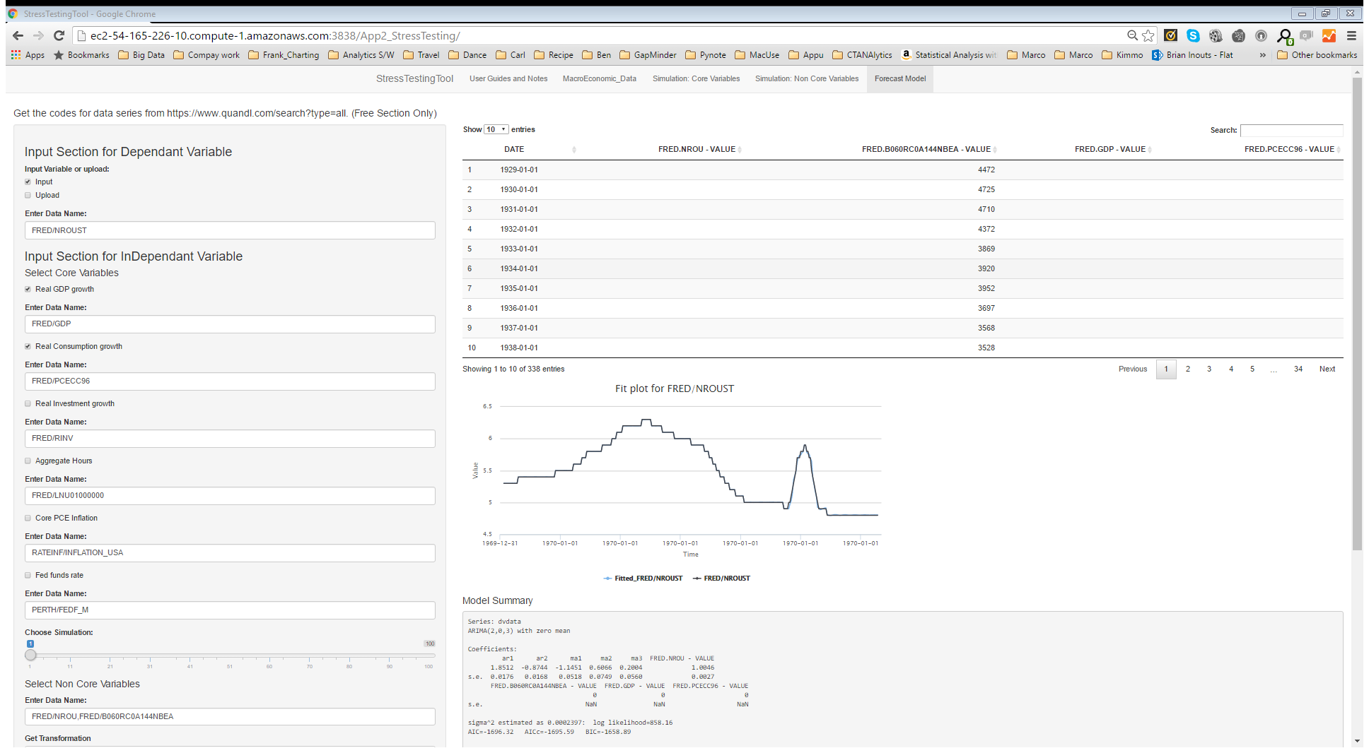

Figure 19: Independent Variables Table

\****Please note that there can be many blanks in this table. What is currently done is the missing values are imputed before the modelling step with the last value or lags and then any row containing blanks after the imputation step, is deleted. Ideally the next step should be to either add code to allow user to select dates or allow user to choose imputation method***

## Output

### Model FIt

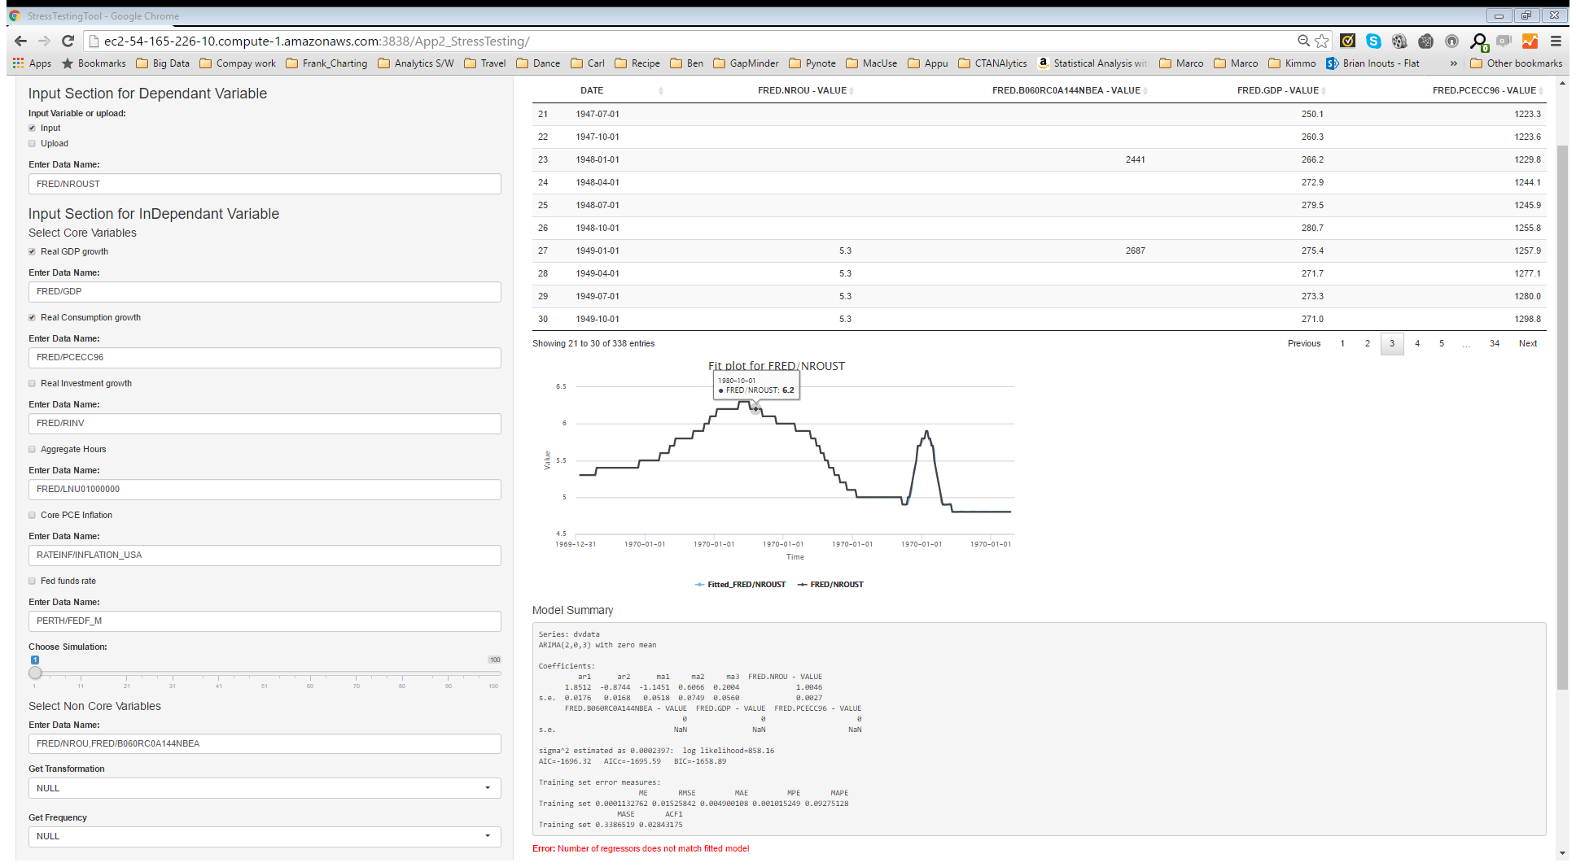

Figure 20: Model Fit

This plot shows us visually how good the model fits the actual data in the forecast period.

### Summary of Model FIt



Figure 1: Model Fit Summary

Here we get some details regarding the developed model in terms of parameter estimates of the input variables, the standard error, significance of the model and the AIC

### Forecast plot

Now by changing the simulation # for the core variables and outlook dropdown for the non-core variables in the input section we can generate the forecasts for our chosen metric

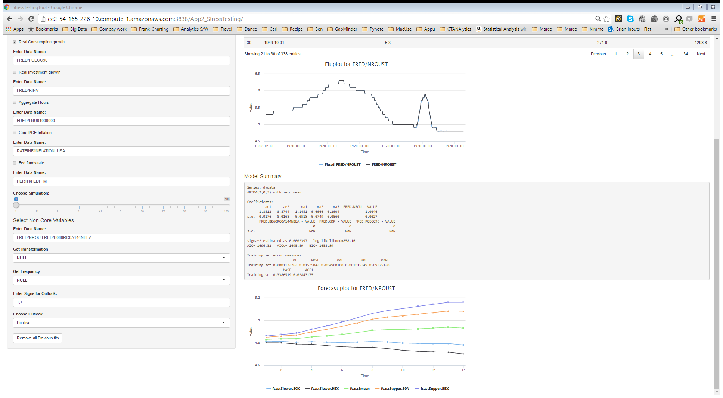

Figure 22: Forecast Plot

# CURRENT DRAWBACKS

1. All macro variables share same settings like transformation, frequency, sign etc. Allowing user to customize these for every variable should give a better model.
2. Drawback2: Part in italics